**Evolving role of a Software:**

Software Evolution is a term which refers to the process of developing software initially, then timely updating it for various reasons, i.e., to add new features or to remove obsolete functionalities etc. The evolution process includes fundamental activities of change analysis, release planning, system implementation and releasing a system to customers.

Today, software takes on a dual role. It is a product and, at the same time, the vehicle for delivering a product. As a product, it delivers the computing potential embodied by computer hardware or, more broadly, a network of computers that are accessible by local hardware. Whether it resides within a cellular phone or operates inside a mainframe computer, software is an information transformer—producing, managing, acquiring, modifying, displaying, or transmitting information that can be as simple as a single bit or as complex as a multimedia presentation. As the vehicle used to deliver the product, software acts as the basis for the control of the computer (operating systems), the communication of information (networks), and the creation and control of other programs (software tools and environments). Software delivers the most important product of today’s time—information.

The cost an impact of these changes are accessed to see how much system is affected by the change and how much it might cost to implement the change. If the proposed changes are accepted, a new release of the software system is planned. During release planning, all the proposed changes (fault repair, adaptation, and new functionality) are considered.

A design is then made on which changes to implement in the next version of the system. The process of change implementation is an iteration of the development process where the revisions to the system are designed, implemented and tested.

Software transforms personal data (e.g., an individual’s financial transactions) so that the data can be more useful in a local context; it manages business information to enhance competitiveness; it provides a gateway to worldwide information networks (e.g., Internet) and provides the means for acquiring information in all of its forms.

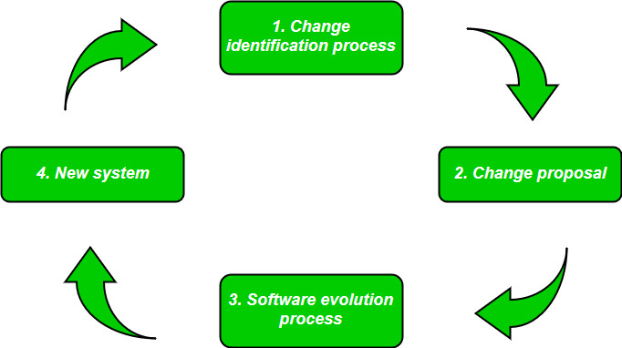

**Laws used for Software Evolution:**

1. **Law of continuing change:**  
   This law states that any software system that represents some real-world reality undergoes continuous change or become progressively less useful in that environment.
2. **Law of increasing complexity:**  
   As an evolving program changes, its structure becomes more complex unless effective efforts are made to avoid this phenomenon.
3. **Law of conservation of organization stability:**  
   Over the lifetime of a program, the rate of development of that program is approximately constant and independent of the resource devoted to system development.
4. **Law of conservation of familiarity:**  
   This law states that during the active lifetime of the program, changes made in the successive release are almost constant